

**Excel Portfolio Project Report**

By Ahmad Butt, DS8 Cohort (Violet)

**Chapter One**

**Introduction**

**Overview:**

As a junior data analyst, I was tasked to analyze a CSV file that contains comprehensive data regarding the educational landscape in Punjab, Pakistan. The data ranged from the precise location of schools, right down to their tehsils and UC’s, to describing when they were first built, how many times they have been upgraded and the status of basic facilities like security, drinking water and toilets. My main job was to analyze these 48,000+ rows of data to generates metrics, so that we could justify the allotment of our funds (833 Million Rupees or 3 Million USD) to improve education across Punjab.

**Programs used:**

* Microsoft Excel to analyze the dataset and make PivotTables to visualize data. However, that option soon proved to be redundant as we got more familiar with PowerBI.
* PowerBI made dynamic dashboards and data visualizations much easier. I was able to have more than 6 graphs connected to different slicers ranging from district, UC, PP name to describing the status of infrastructure and facilities of schools. A dashboard snippet is shared on the next page.
* Microsoft Word to make this report and present my findings, thoughts and budget allocations with relevant screenshots from PowerBI’s dashboard, highlighting important metrics.

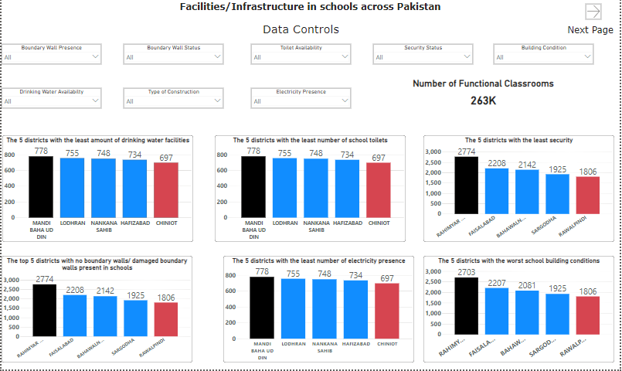

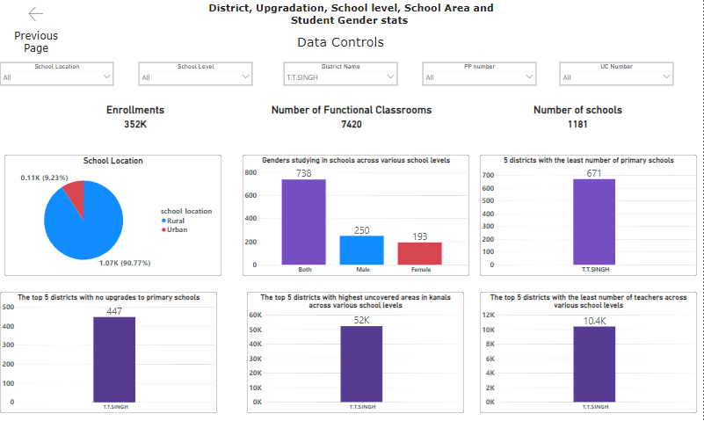

**Chapter Two**

**Documentation of Procedures and Budget Allocation**

**Procedures used:**

The data source file provided has already been described in Chapter One above. According to my research, it mostly resembles the dataset provided at this link:

[https://sis.punjab.gov.pk/](https://sis.punjab.gov.pk/%20)

As for the procedures, there were no duplicates in the unique identifier columns or complete blank rows anywhere in the data. I checked this through the **conditional formatting option** in **Excel.** Granted, there were empties in various columns such as upgradation_year etc., but that didn’t affect the purpose of the record as it had other vital information like facilities/infrastructure status/number of teachers etc., present.

However, while loading the workbook in **PowerBI** and going on the transform data option, the power query editor identified errors in the **Moza** column of the data, where some specific records had the #NAME error. I fixed that using the “replace error with” option in the power query editor and replaced #NAME with null.

Almost all my metrics were calculated by dragging and aggregating various fields in the PivotTable option. Sum and Count were the aggregators used the most. Here are some metrics and their PivotTable and PowerBI representations:

1. List the names of the 5 districts with the lowest availability of drinking water facilities in schools.

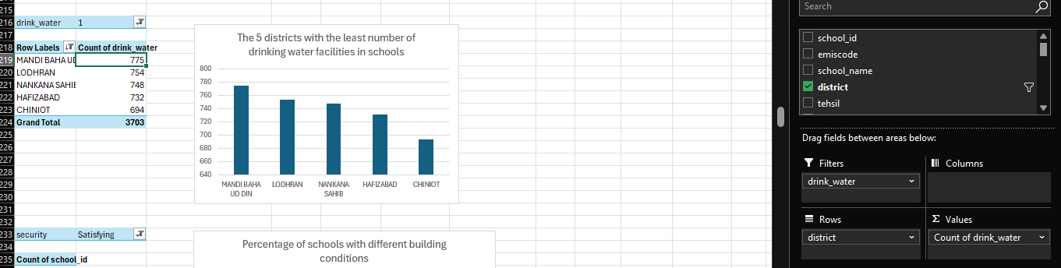

The same table in Power BI dashboard using slicers and filters:

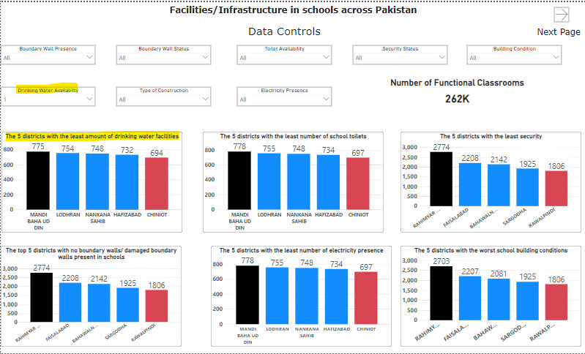

1. List the names of the 5 districts with the lowest availability of electricity in schools.

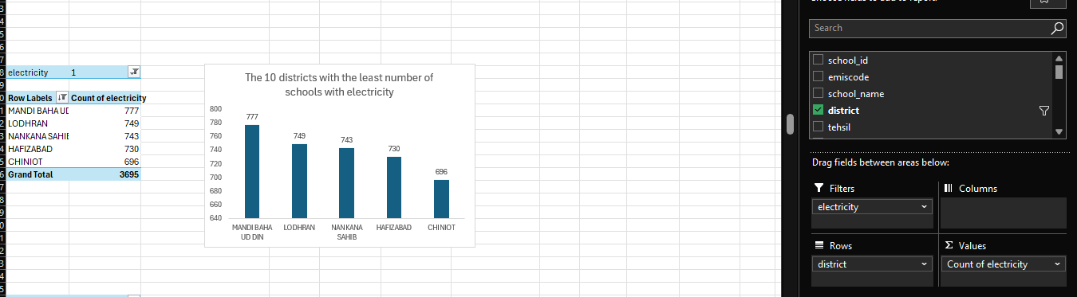

**Budget allocation assumptions:**

There are some assumptions we will be considering while allocating the budget.

* The money allocated, i.e. 2 million for facilities etc., is per district. It is not based on the number of schools. We will be allocating funds to the 5 districts that fare the worst in that category, as are described and written in the Excel question spreadsheet as well.
* All district names, NA, PP, UC number and school location can be easily accessed in the dashboard. Hence, district names will not be repeated here for conciseness.
* Infrastructure costs contain 5 parameters. They are toilets, boundary walls, functional classrooms, security and building condition. The cost mentioned in fixing these issues is 5 million. We will be dividing this cost unequally, with toilets and security both receiving 0.5 million Rupees, whereas the three remaining will receive 1.5 million each since they are costly and more important to develop.
* Facilities also contain various parameters such as playgrounds, labs, electricity and water facilities. Playground and labs will receive 0.9 million each, whereas 0.10 million will be reserved for electricity and water facilities.
* However, the marketing and ground teams will have to play a huge part in making sure the budget allocation reaches the deserving schools as the money allotted per district for certain parameters will not be enough to cover all the schools. For example, there are not a lot of schools lacking in water and toilet facilities. As an example, if we take Mandi Bahauddin District, it has 778 total schools:

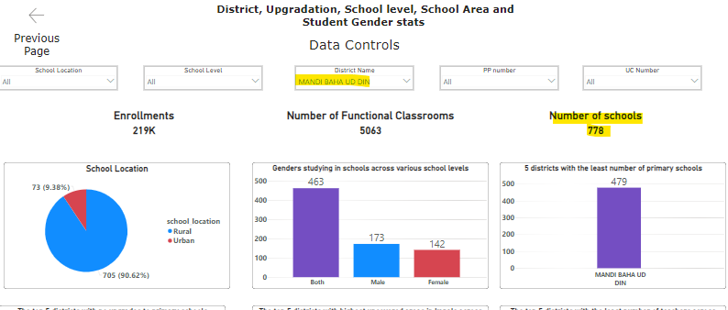

And 777 of them have toilet facilities:

Similar cases are seen in the other districts, with only about 4-5 schools at max not having the water or toilet facilities. These schools can easily be catered to by the allotted budget. However, for parameters like security status, it is not so straightforward, as there are more than 100 schools in districts not having any security. For example, in Rahimyar Khan district:

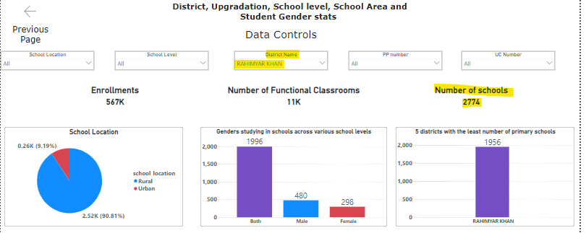

There are a total of 2774 schools.

However, security is not available in 1111 of these schools:

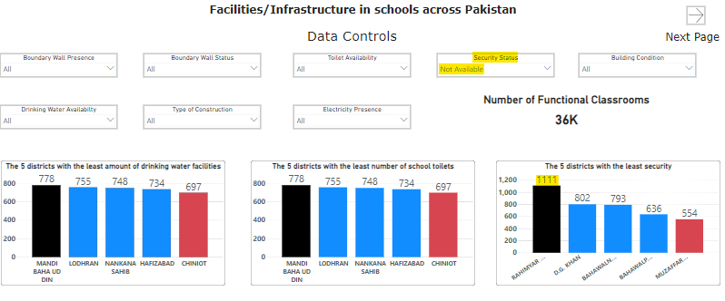

It will be impossible to cater all these 1111 schools for security using the allotted budget. Hence, it is the responsibility of the ground and marketing team to meet with the respective PP, UC representatives of that district/tehsil and make sure that the most deserving schools get the funds first. The rest of the schools can get the funds in the next phases. The phases are explained in a subsequent section below.

* Upgrading facilities and infrastructure will be a priority so that new eager students are encouraged to attend school and existing students are encouraged to pursue higher education in secondary schools. However, new primary schools will be considered too since there is a lot of class congestion, with more than 45 students on average in a single class.
* Separate schools for males and females are vital as well, since a big majority of the schools are in rural areas, with parents there not eager for their daughters to be studying in a co-education setup. Separate schools for both males and females will help take care of that issue and encourage more women to enroll and pursue education.

**Justification for funds:**

Toilets and security received a lesser share of funds since they are not that expensive to initiate and put in place. Security guards receive fixed salaries per month that are less than 70,000 PKR.

On the other hand, construction costs and material in Pakistan have gone up, hence boundary walls and improving building condition gets a larger share of funds. Many rural schools stretch for kilometers, and it is important to cover all points via a wall to avoid outside inconveniences.

Improving building conditions includes new paints, tiles, drainage work etc. That drives up the cost.

Increasing functioning classrooms means buying new furniture, smart boards, computers and other various multimedia to keep with today’s demands. This costs huge sums of money, hence the larger allocation.

The same case can be said for facilities. Developing playgrounds and labs requires cultivating uncovered areas in various kanals; this requires labor and machinery which is expensive due to fuel costs. Labs require standard equipment, which is costly, for example, the solutions in the chemistry lab. Comparatively, water problems can be solved by placing various filtered coolers across the campus and the electric problems can easily be solved by 2-3 electricians working on daily wages.

**Budget allocation:**

* Fixing electricity in the 5 districts having lowest availability.

The cost is cost 5*0.1 Million= **0.5 Million**

* Similarly, for the 5 districts having lowest availability of water facilities:

The cost 5*0.1=**0.5 Million**

* Similar calculations for the 5 districts having lowest availability of toilets:

The cost 5*0.25= **1.25 Million**

* Security costs

5*0.25= **1.25 Million**

* Boundary Walls

5*1.5= **7.5 Million**

* Functional Classrooms cost

5*1.5= **7.5 Million**

* Improving building conditions

5*1.5= **7.5 Million**

* Developing playgrounds and labs ( this is based on cultivating and developing the unused area of schools in kanals)

(5*1.5) + (5*1.5)= **15 Million**

**Total for Infrastructure and Facilities= 41 Million PKR**

**Budget allocation for upgradation/new schools:**

* Building new primary schools for the 5 districts with the least number of primary schools

5*10= **50 Million**

* Upgrading primary schools that haven’t been upgraded since they were first constructed

5*10= **50 Million**

* Making separate schools for boys and girls

(5*20)= **100 Million**

Total= 50+50+100= **200 Million PKR**

**Grand Total: 200+41= 241 Million PKR**

**Budget conclusion:**

A budget allocation of **241 Million PKR** is well within our total budget of **833 Million PKR**. We can call this phase of operation**, Phase 1**, and once all these upgrades have been made, we can easily replicate 2-3 more phases like this, starting with the next 5 districts that are the most affected.

If we perform 3 Phases, the total cost equates to **723 Million PKR,** which still leaves us with **110 Million PKR.** If we separate out a very generous **30-35 Million PKR** for marketing and other miscellaneous costs, we are still left with **75 Million PKR.** This money can be utilized for improving the remaining schools, or for a nobler cause, such as arranging scholarships for higher studies for deserving students.

An average phase of upgradations will bring about changes to more than 50,000 schools. This will generate employment and encouragement among students, especially females in rural areas, to continue their studies or take up studying if they were reluctant before. The budget plan makes sure that there are ample funds left for marketing purposes as well.

**Marketing Strategies:**

Effective communication and marketing strategies will ensure these initiatives reach their target audience and gain community support:

* **Localized Social Media Campaigns:**

Highlight the specific improvements made to schools in targeted districts. Share success stories and showcase the enhanced facilities and new schools.

* **Gender-Sensitive Outreach Programs:**

Run campaigns emphasizing the availability of separate facilities for boys and girls in middle and high schools, which is crucial in culturally sensitive regions. These campaigns can be advertisements on TV/radio in the local language, or in person marketing campaigns like an open house etc.

* **Community Information Events:**

Host informational events in high-need districts to educate families on the new resources and encourage school attendance.

* **Collaborative Partnerships:**

Partner with NGOs, community leaders, and government bodies to extend the reach of these campaigns and increase enrollment.

**Report Summary:**

The fund allocation plan is based on insights derived from the dataset, revealing urgent needs in infrastructure, school facilities, and access to education, particularly for girls and rural communities. By targeting these areas through the proposed initiatives, the allocation of 833 million PKR will drive significant improvements in the quality and accessibility of education across Punjab. The marketing strategies further support these efforts by promoting awareness and community engagement.

This comprehensive allocation strategy will maximize the impact of the funds, leaving plenty of funds for the marketing team to utilize as well. This will ensure a safe, inclusive, and enriched learning environment for students in Punjab.

Moreover, the comprehensive PowerBI dashboard for this data is published online as well and can be accessed through the following QR code:



A screenshot of the dashboard published online:

